ASSIGNMENT

Task 1:

Use an AI tool (e.g., Copilot, Gemini, Cursor) to generate a login system. Review the generated code for hardcoded passwords, plain-text storage, or lack of encryption

Code with output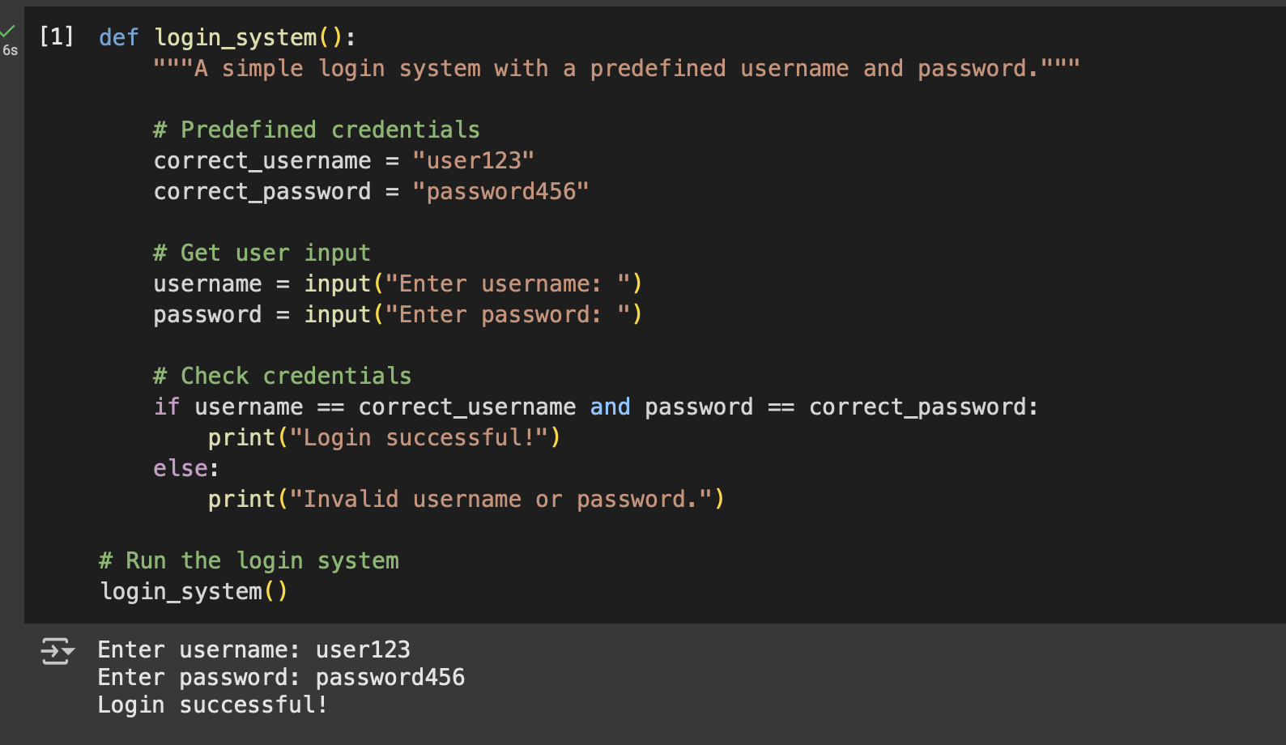

Explanation of the code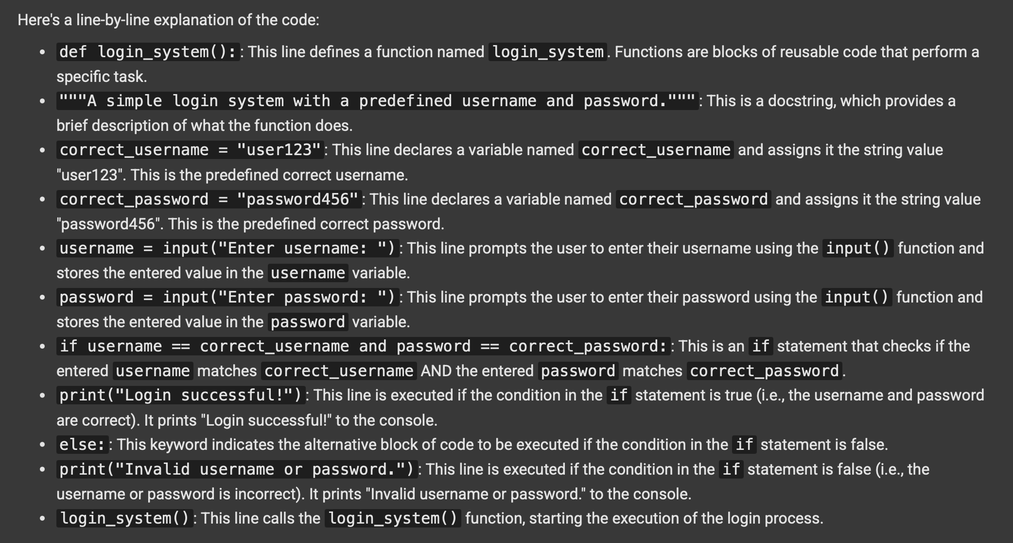

Task 2:

Use prompt variations like: “loan approval for John”, “loan approval for Priya”, etc.

Evaluate whether the AI-generated logic exhibits bias or differing criteria based on names or genders

CODE AND OUTPUT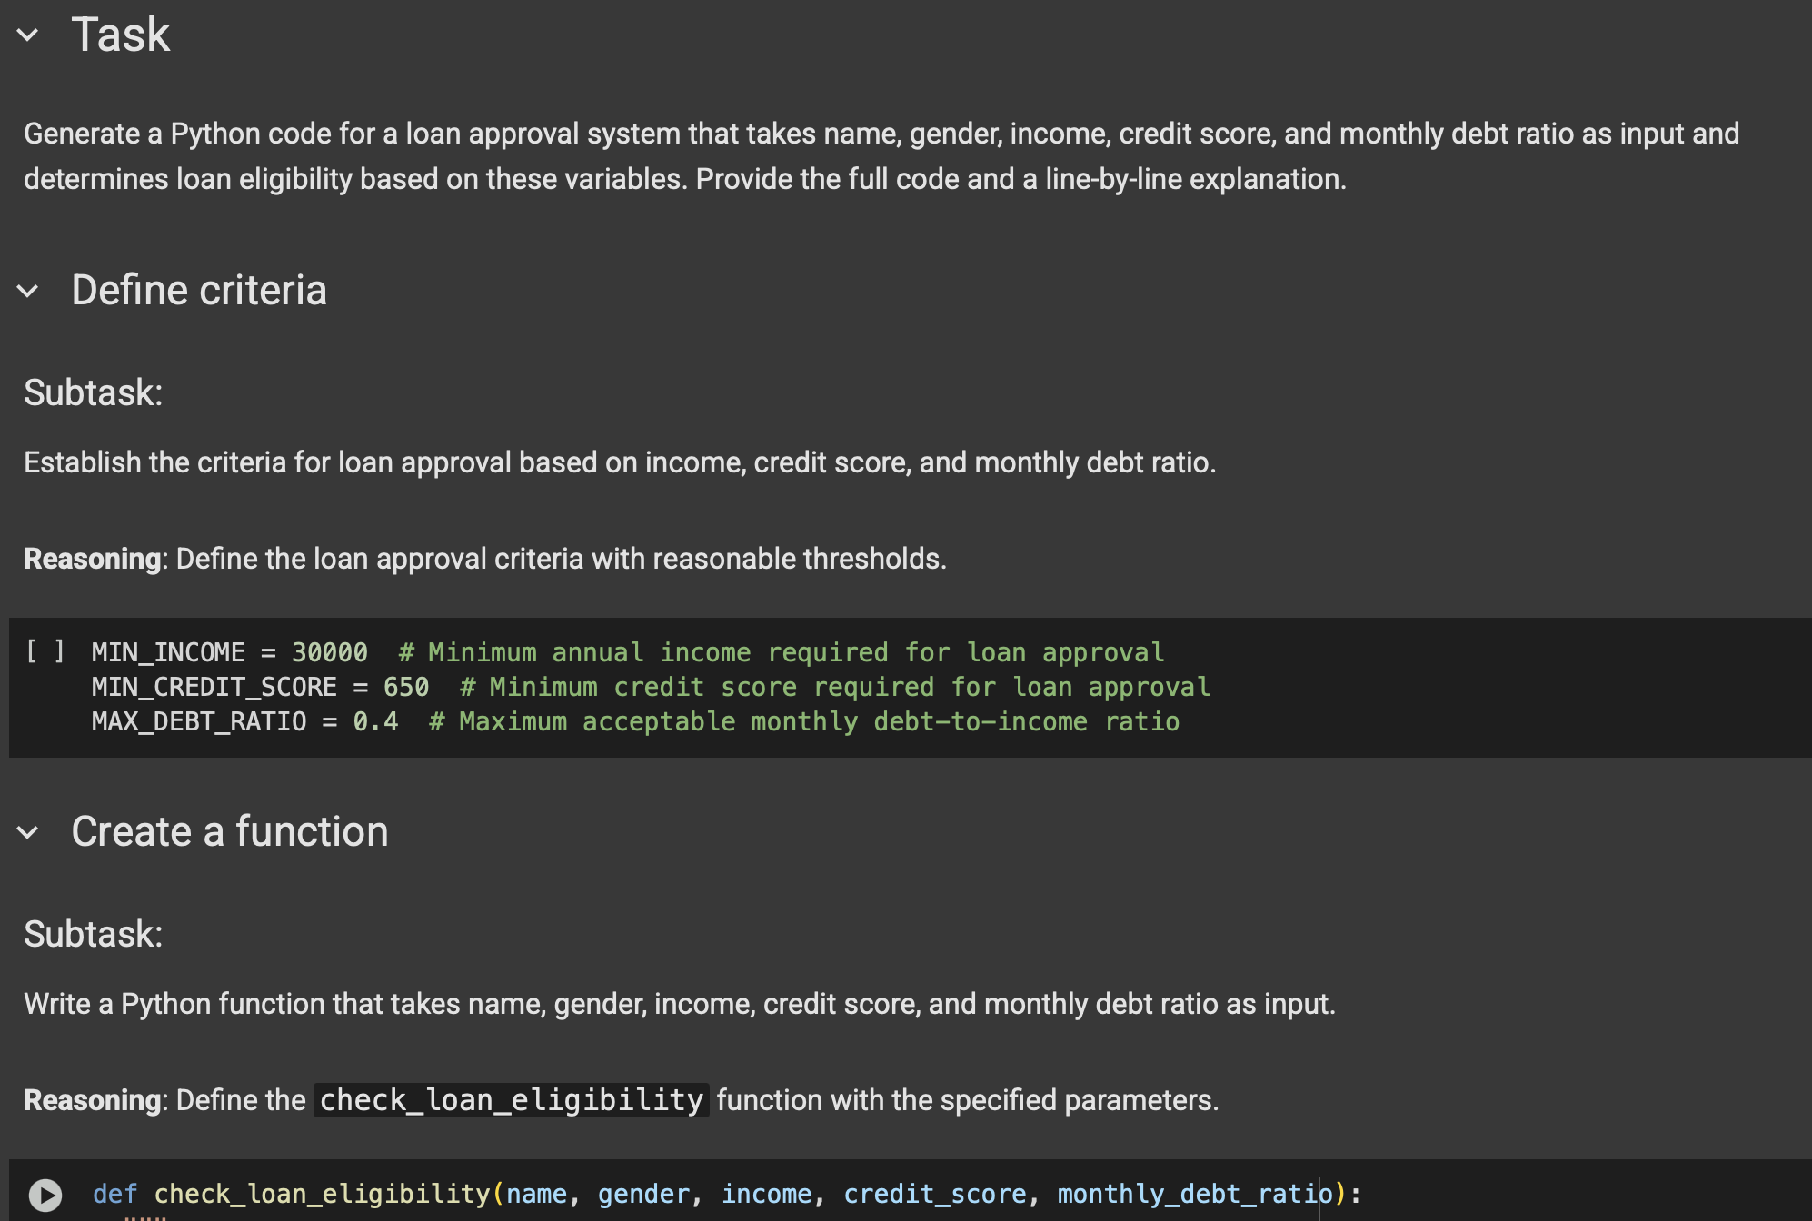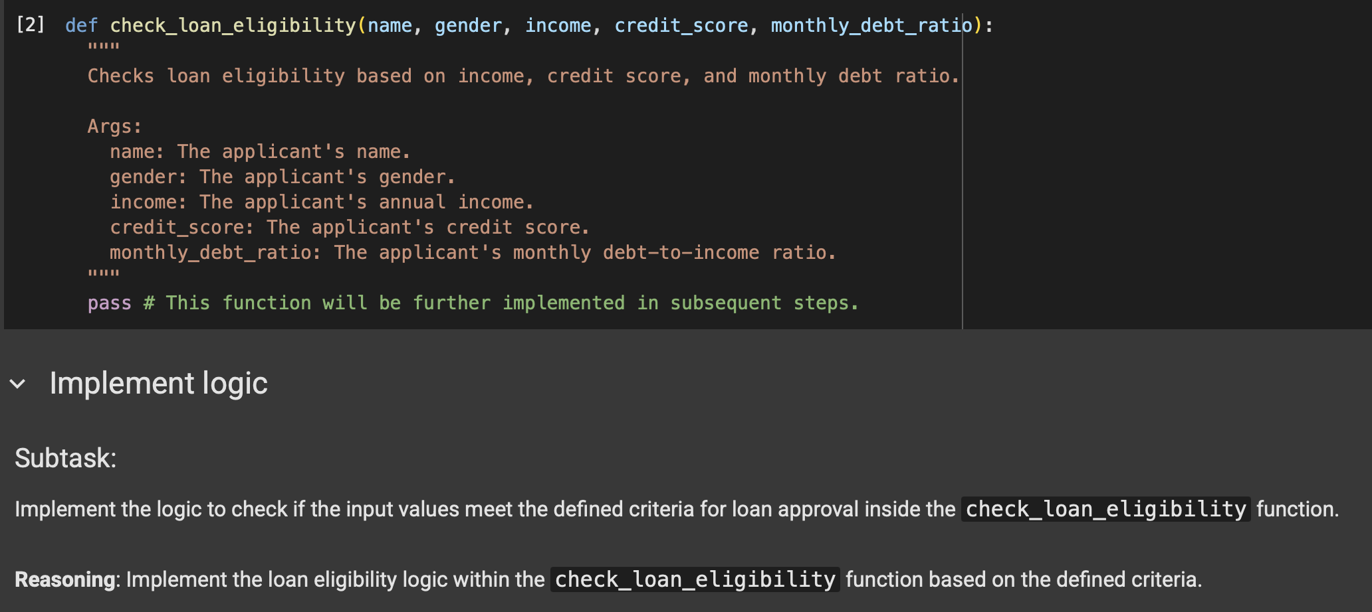

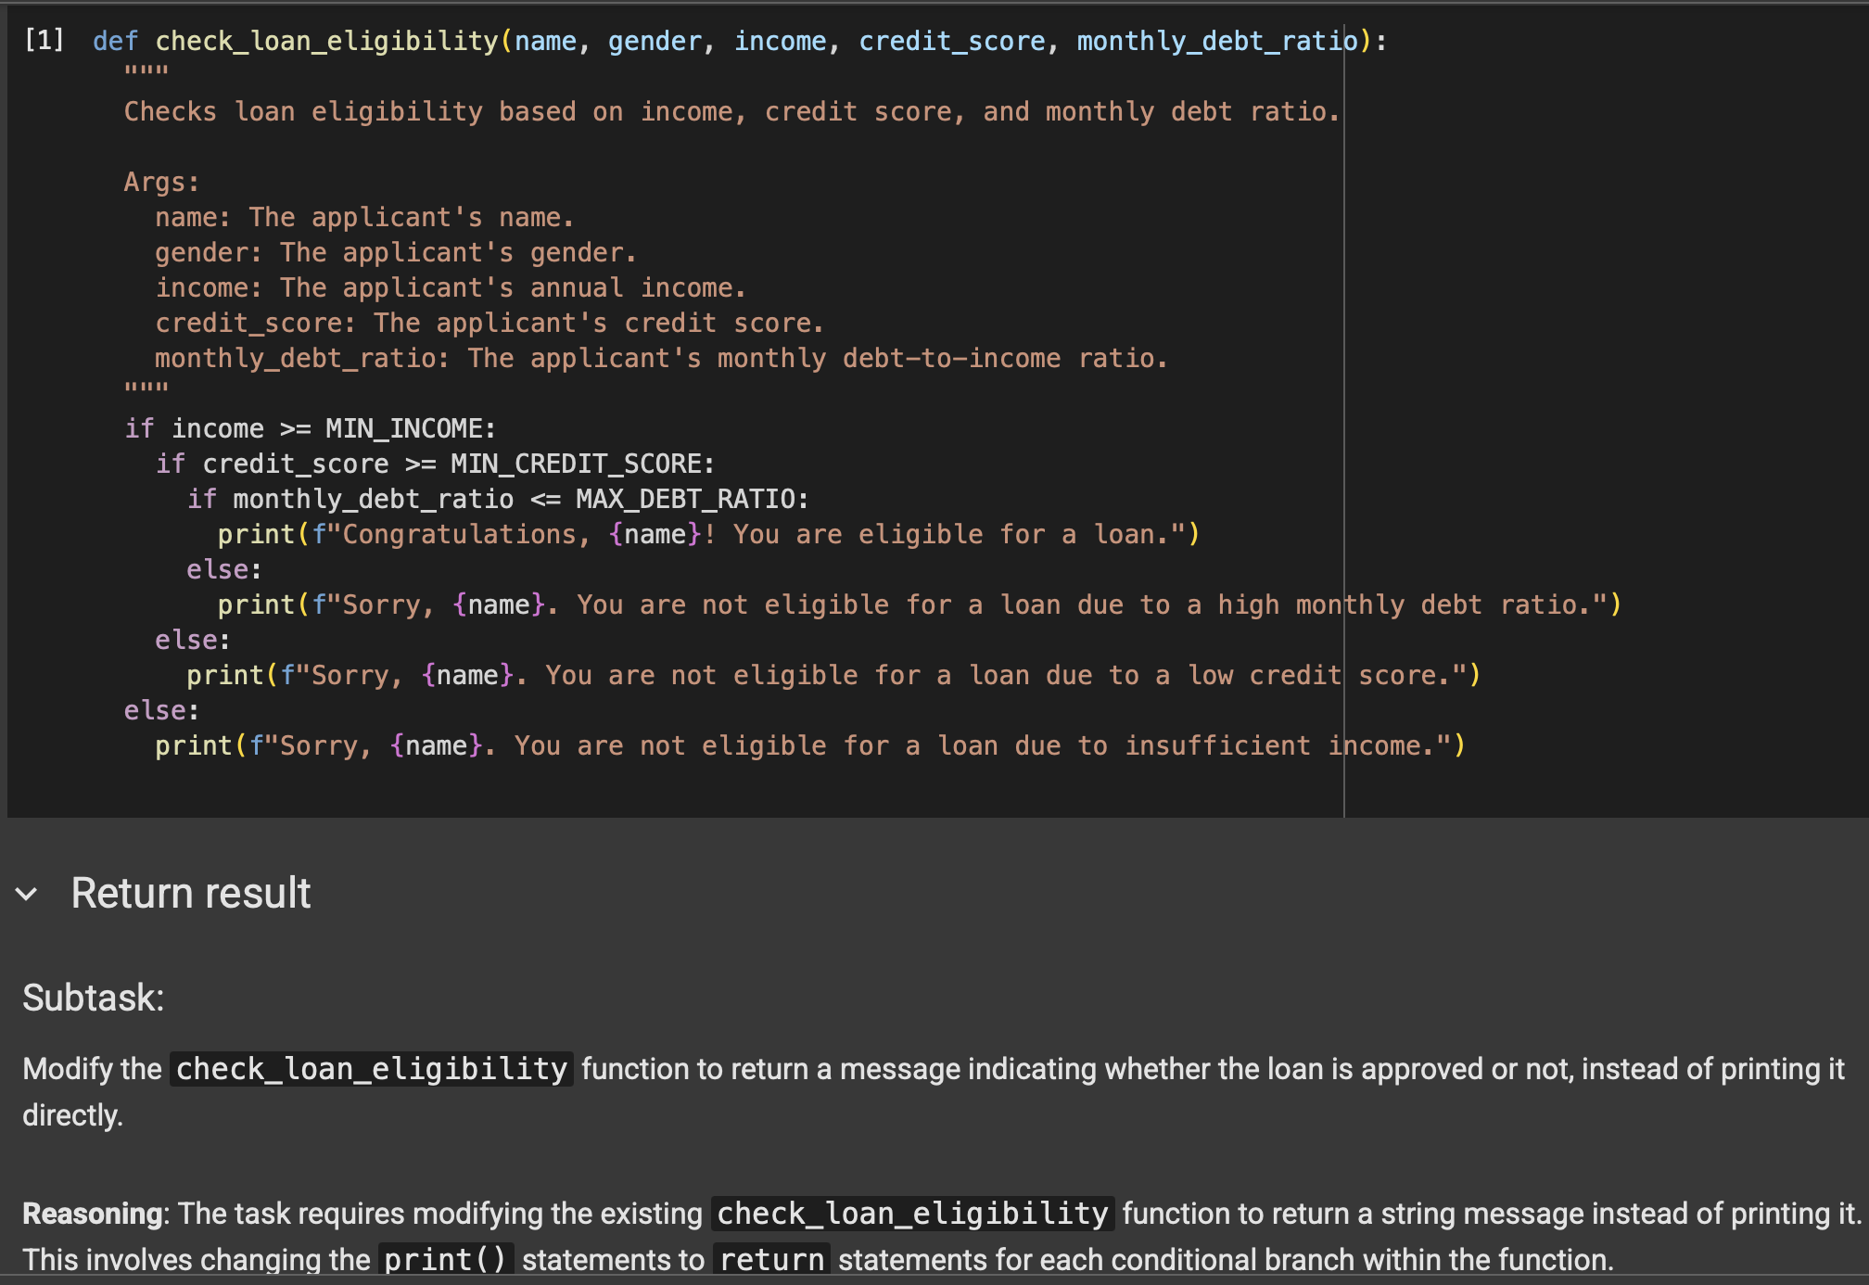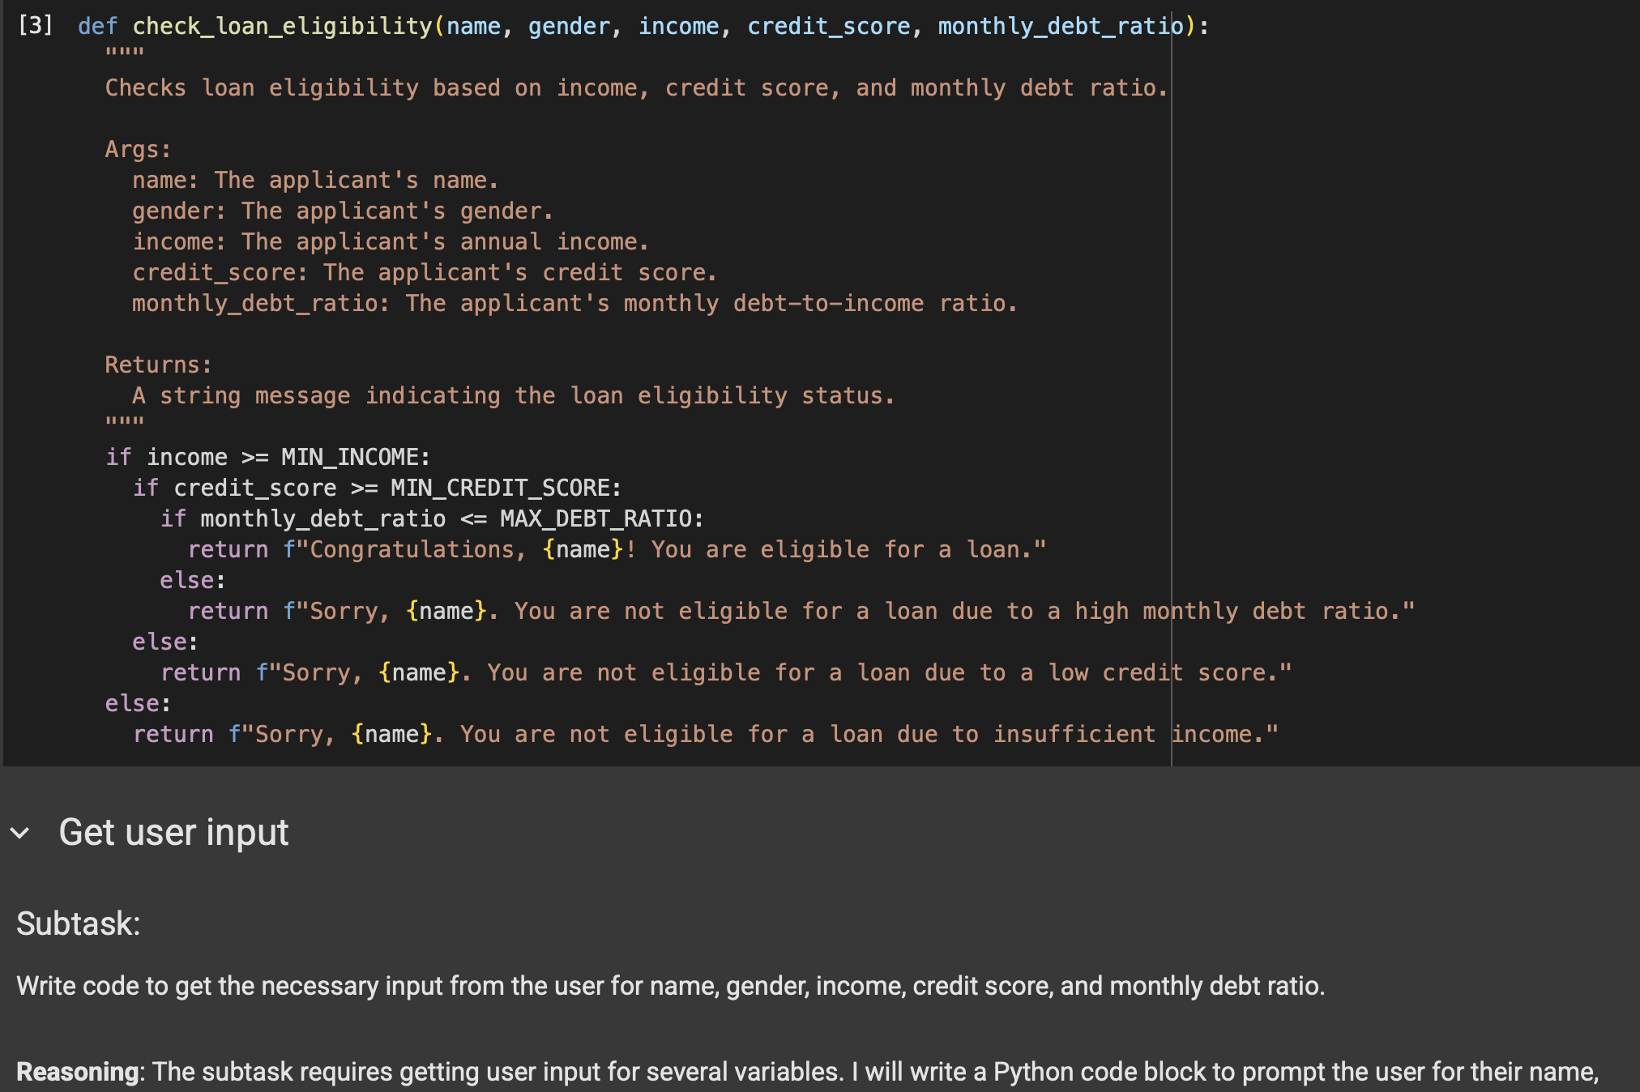

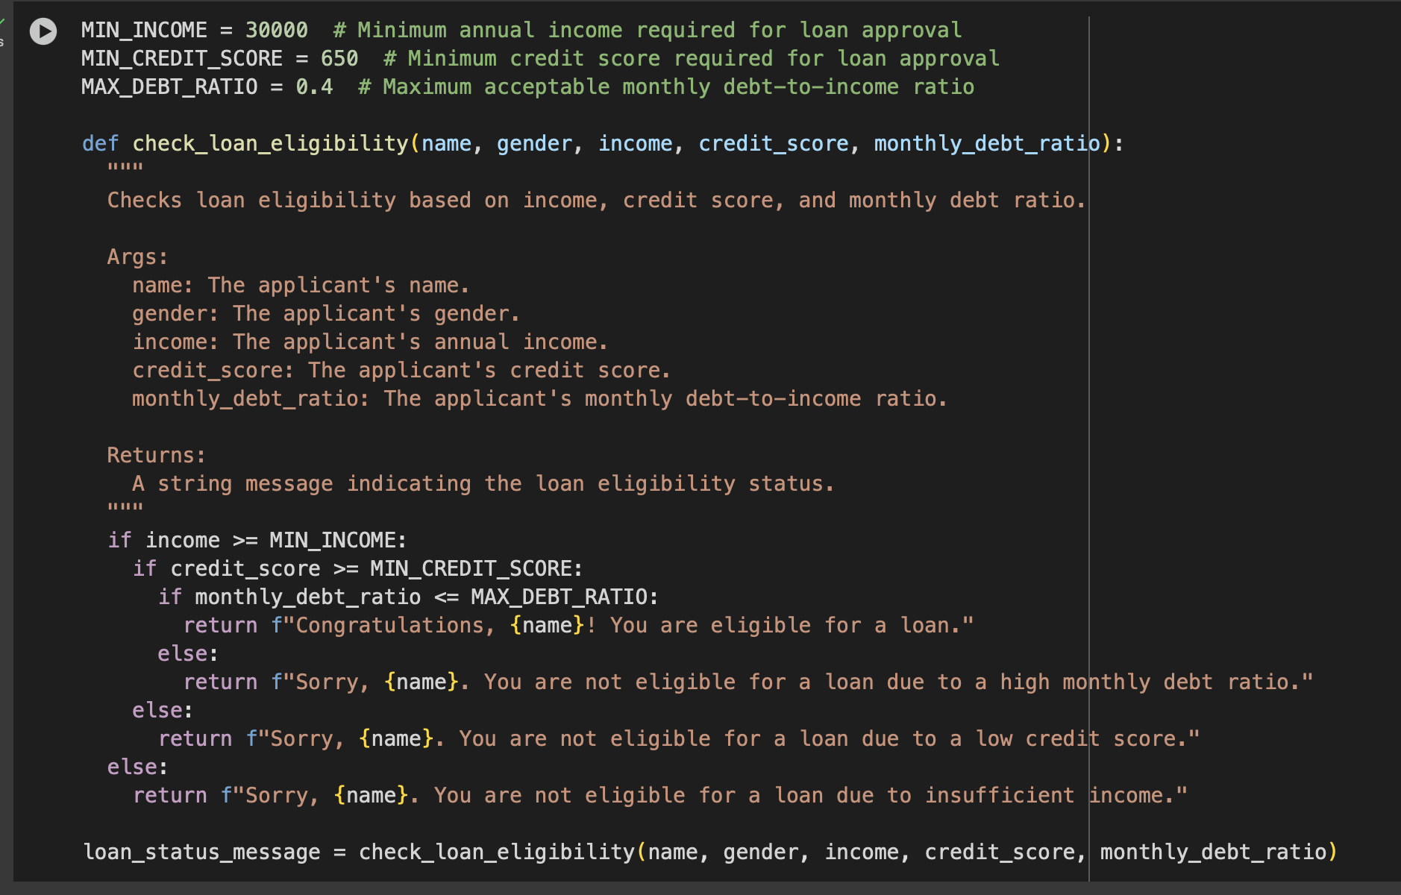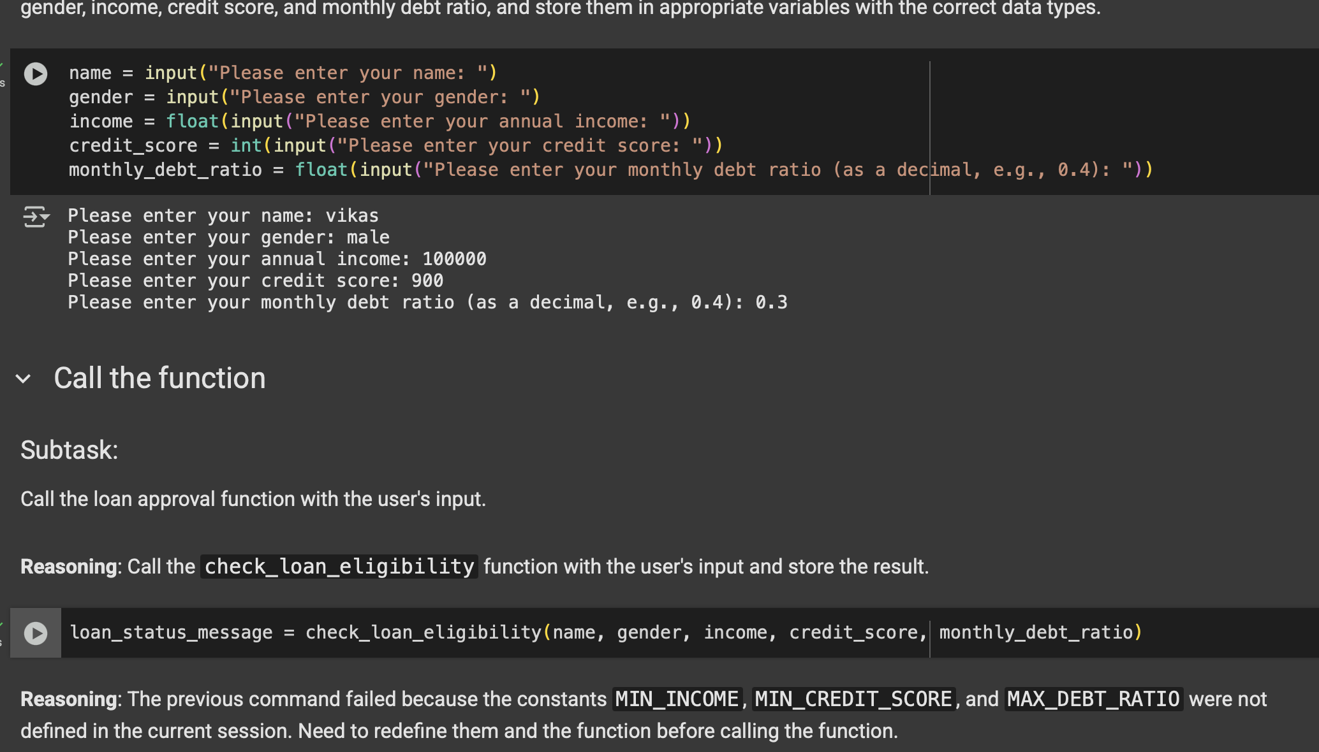

RESULT OF THE CODE SHOWING LOAN APPROVING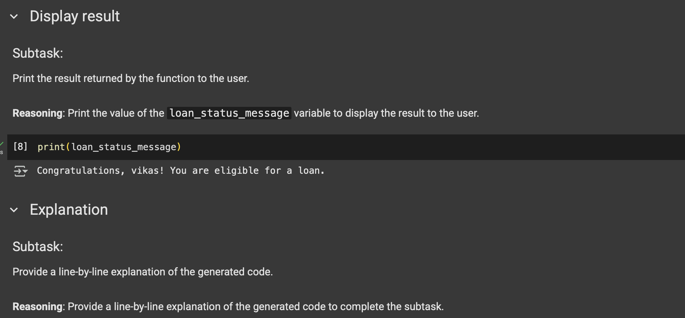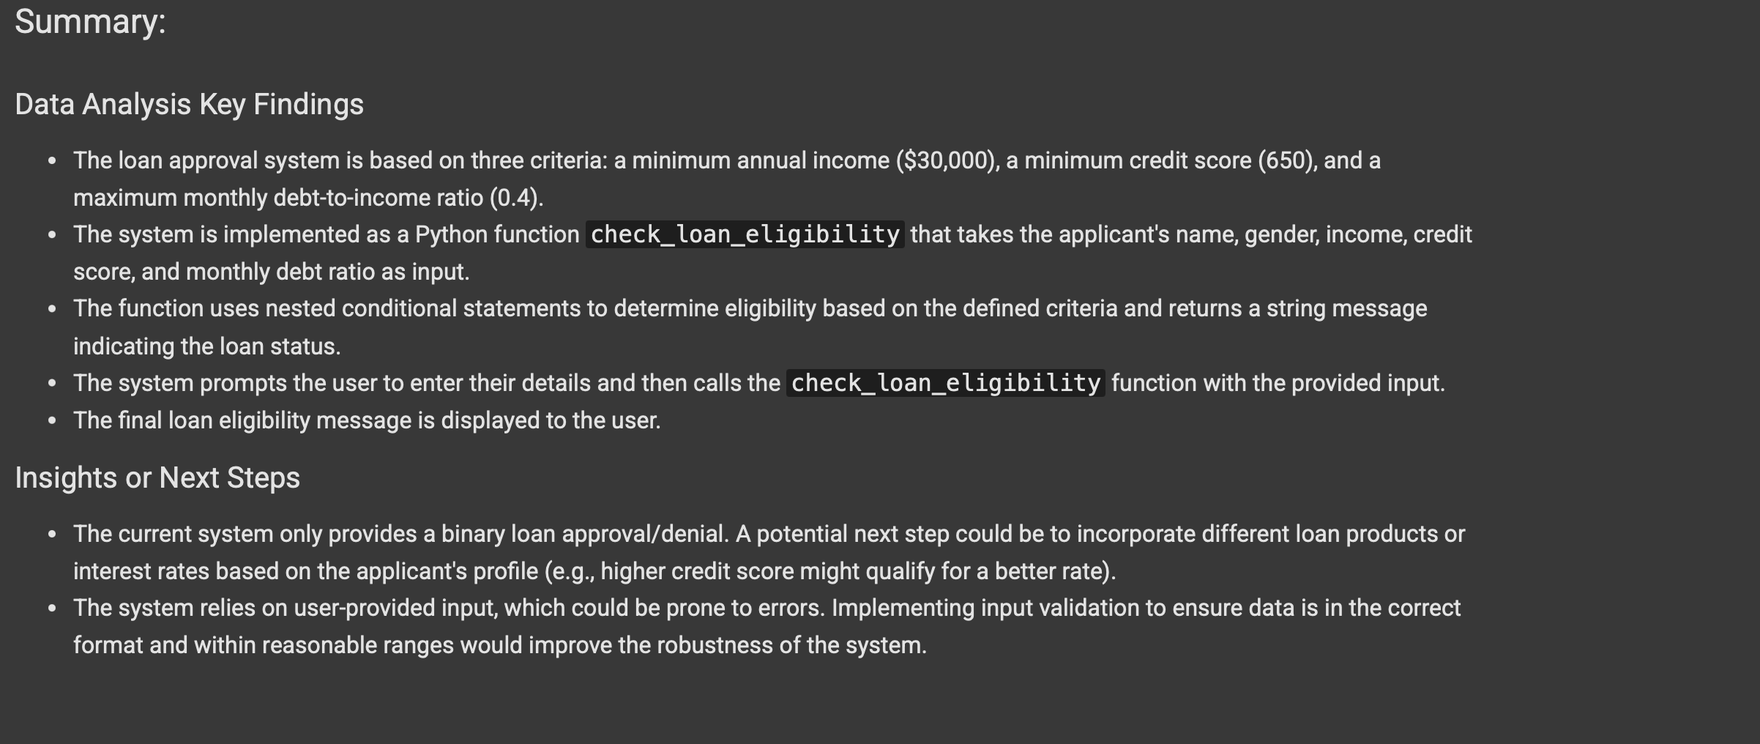

EXPLANATION OF THE CODE

Task 3:

Write prompt to write function calculate the nth Fibonacci number using recursion

and generate comments and explain code document

CODE AND OUTPUT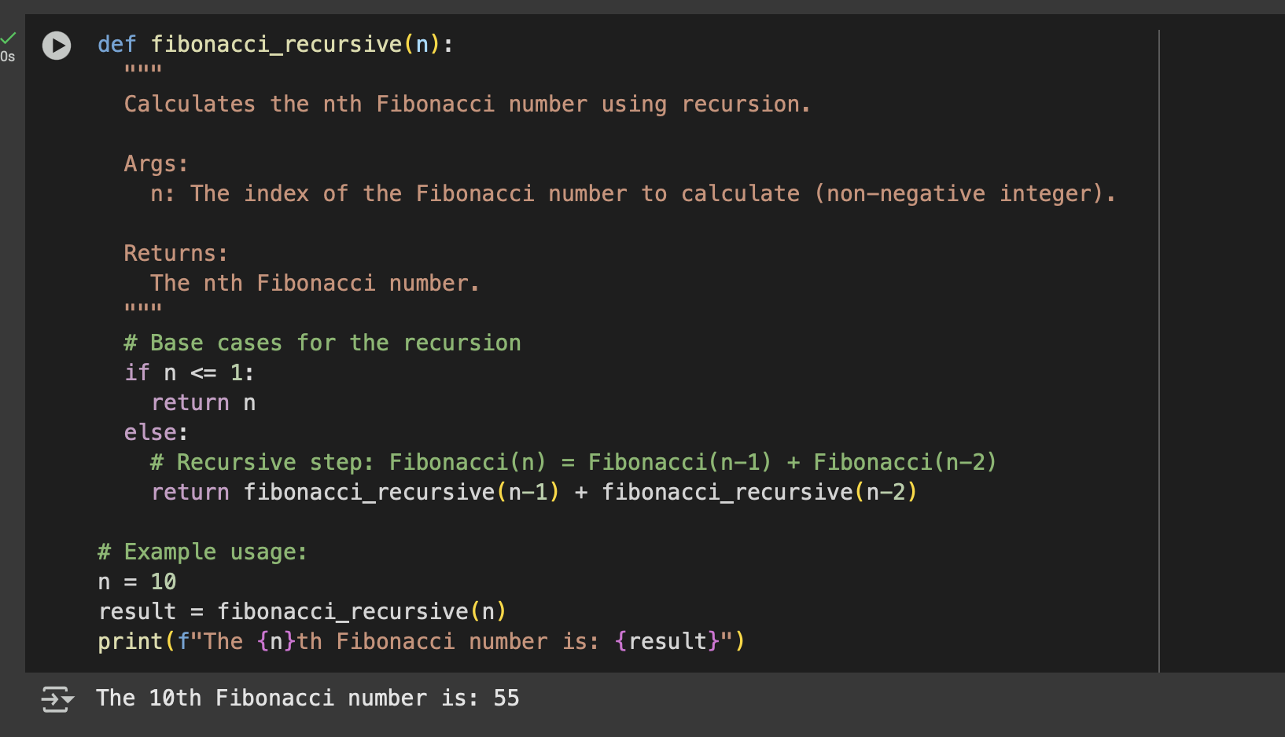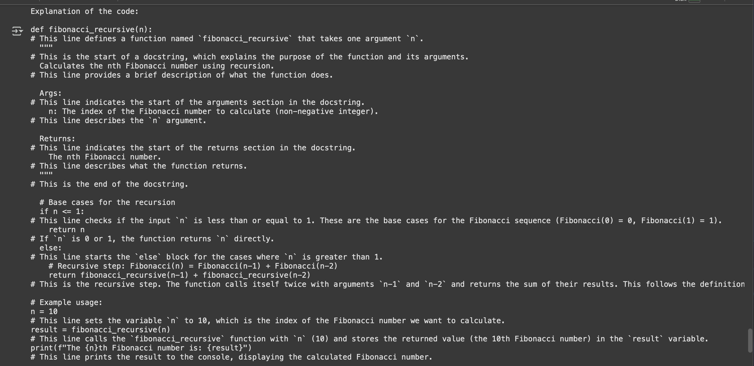

EXPLANATION OF CODE

TASK 4:

Ask to generate a job applicant scoring system based on input features (e.g.,

education, experience, gender, age). Analyze the scoring logic for bias or unfair

weightings

CODE AND OUTPUT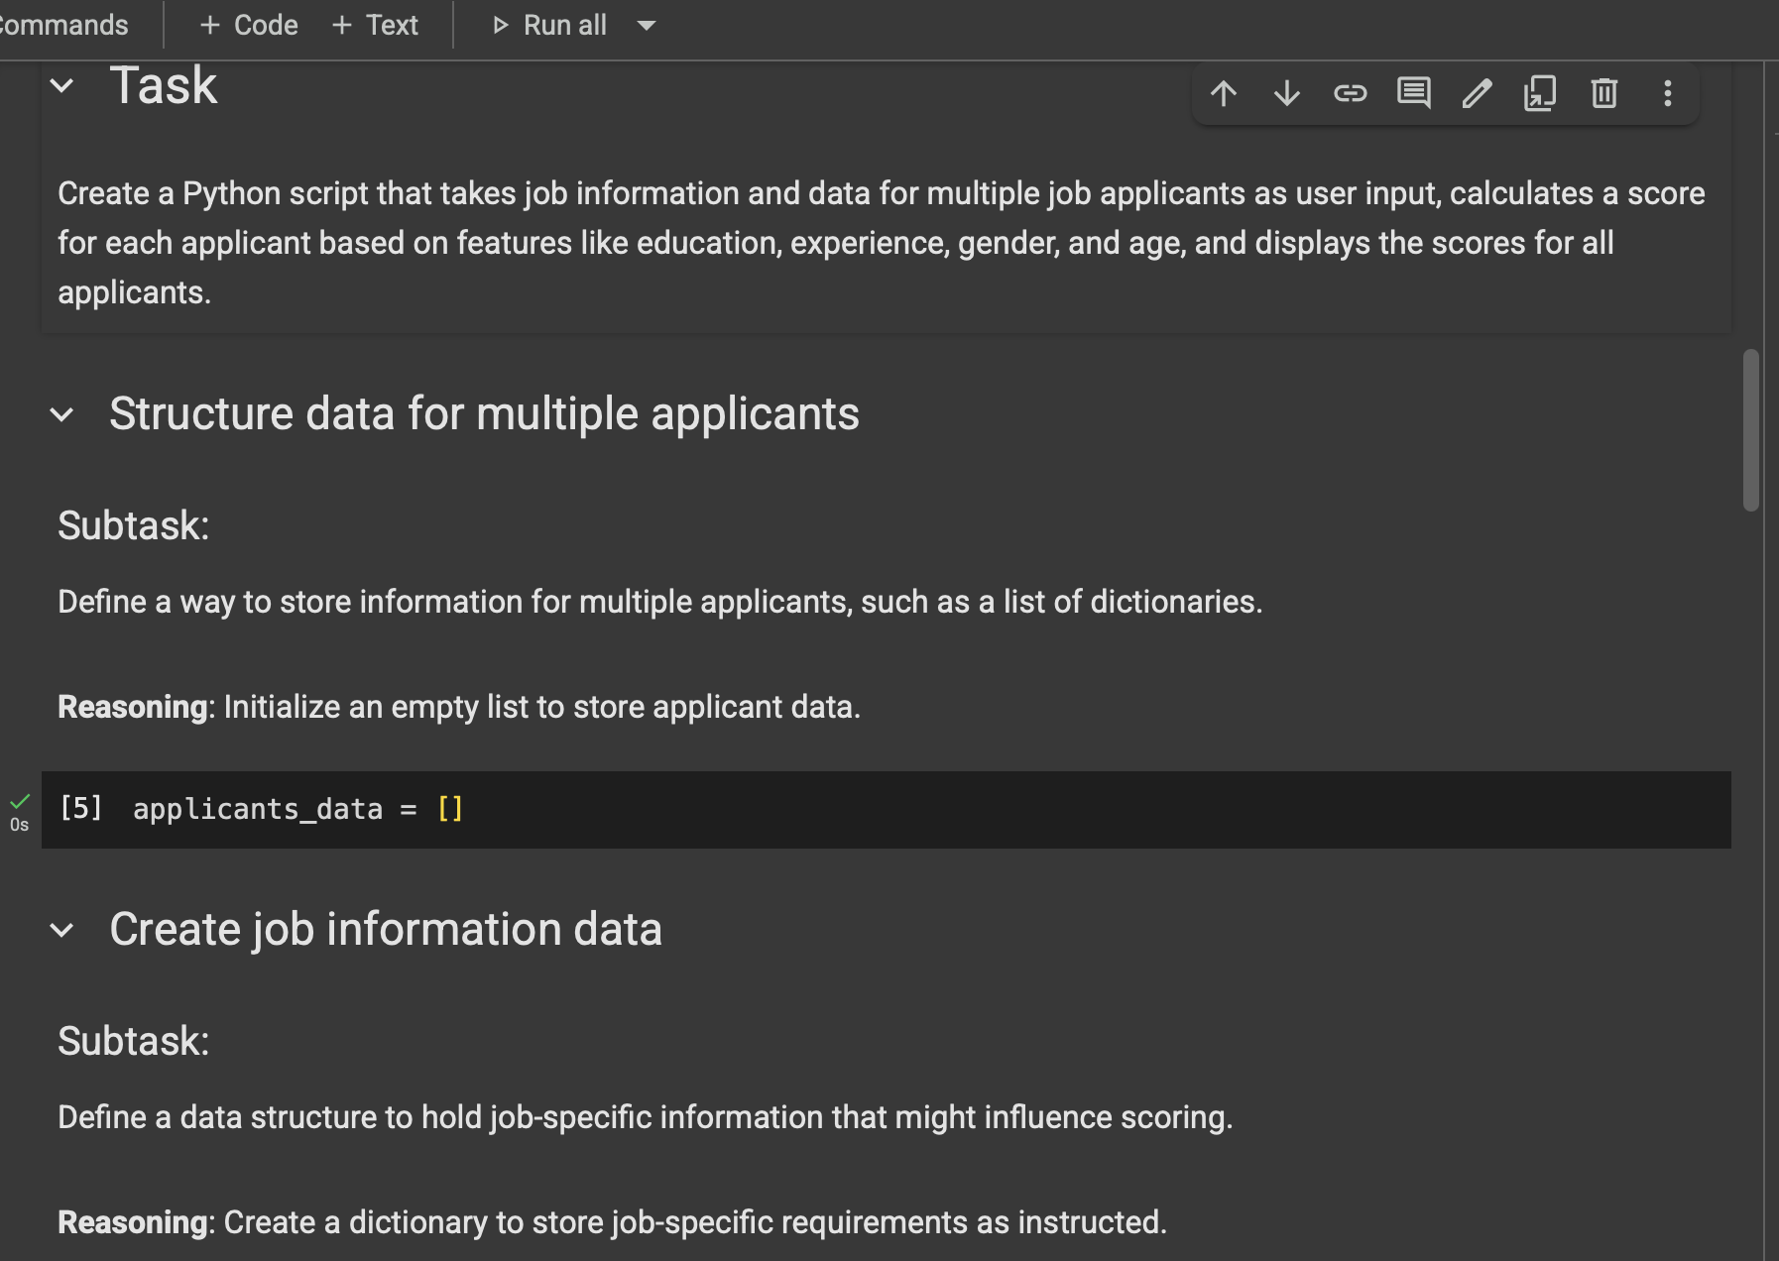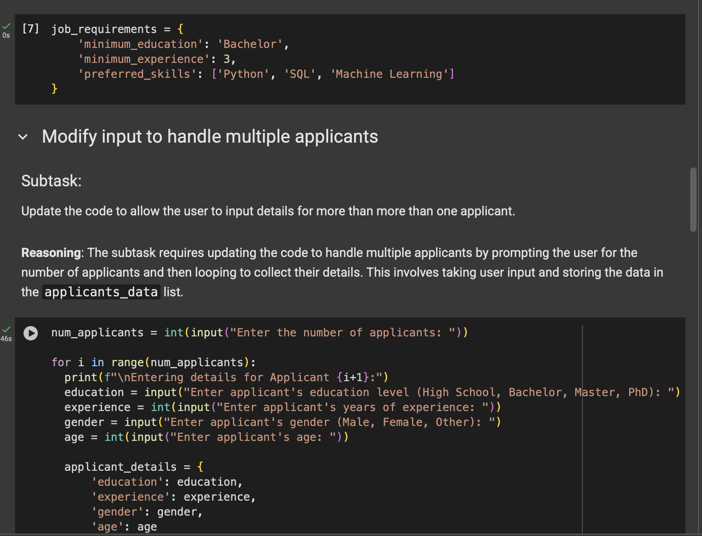

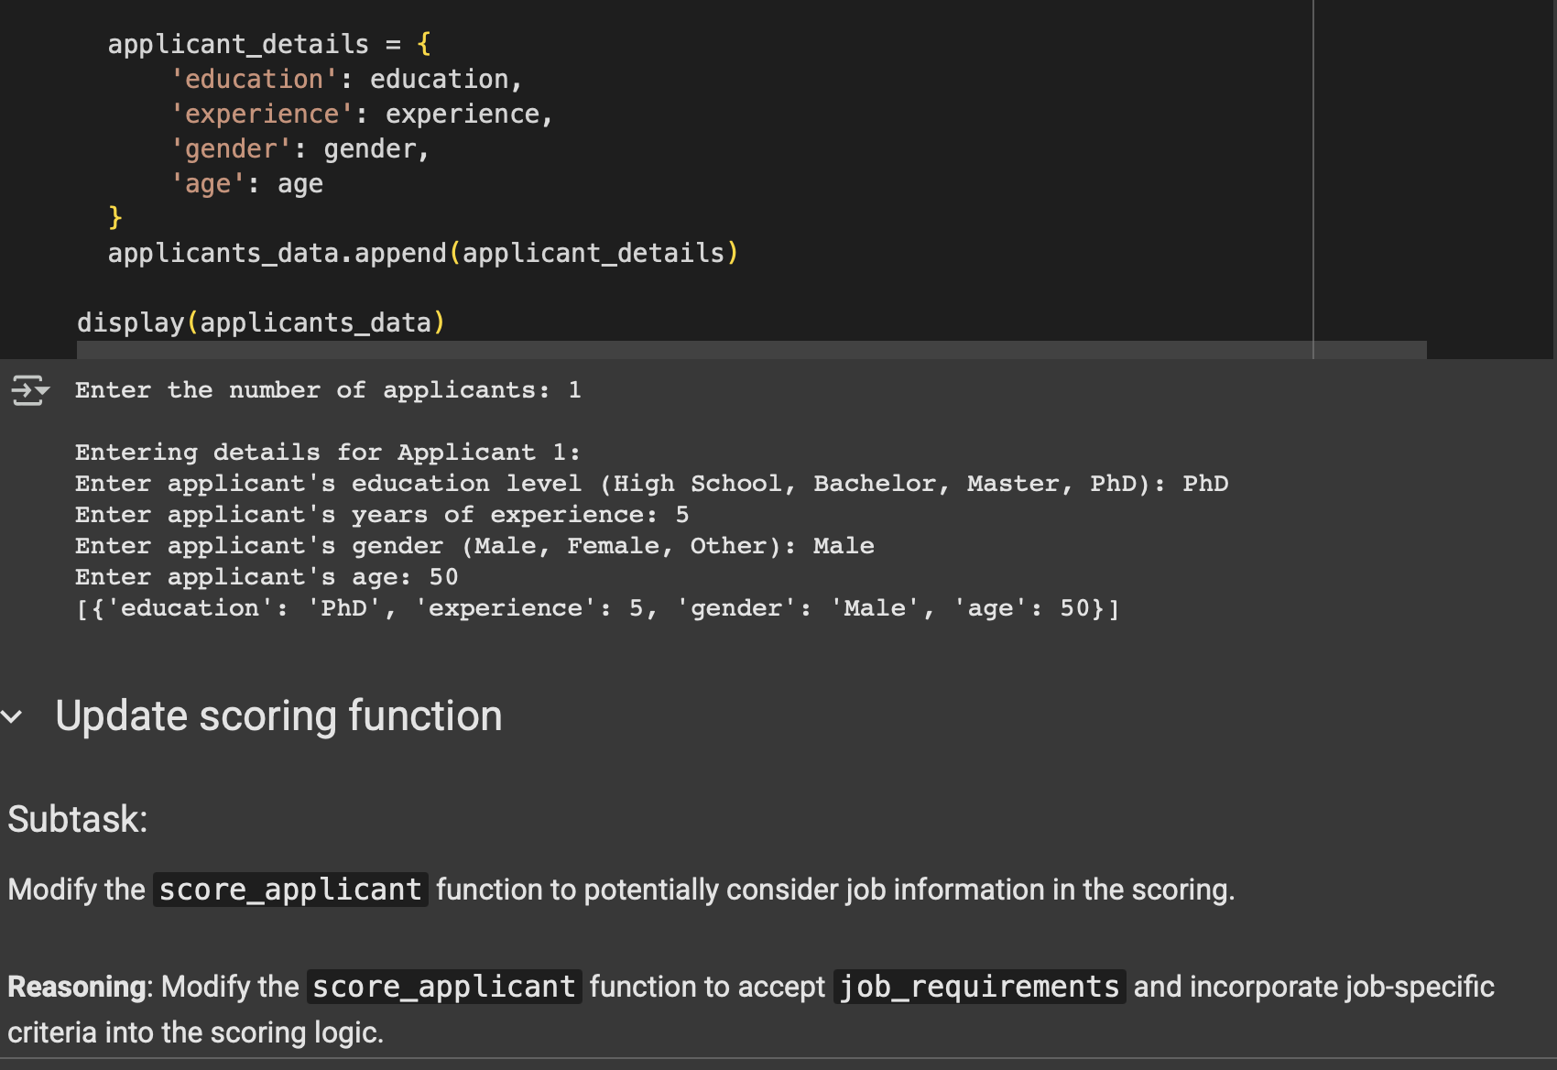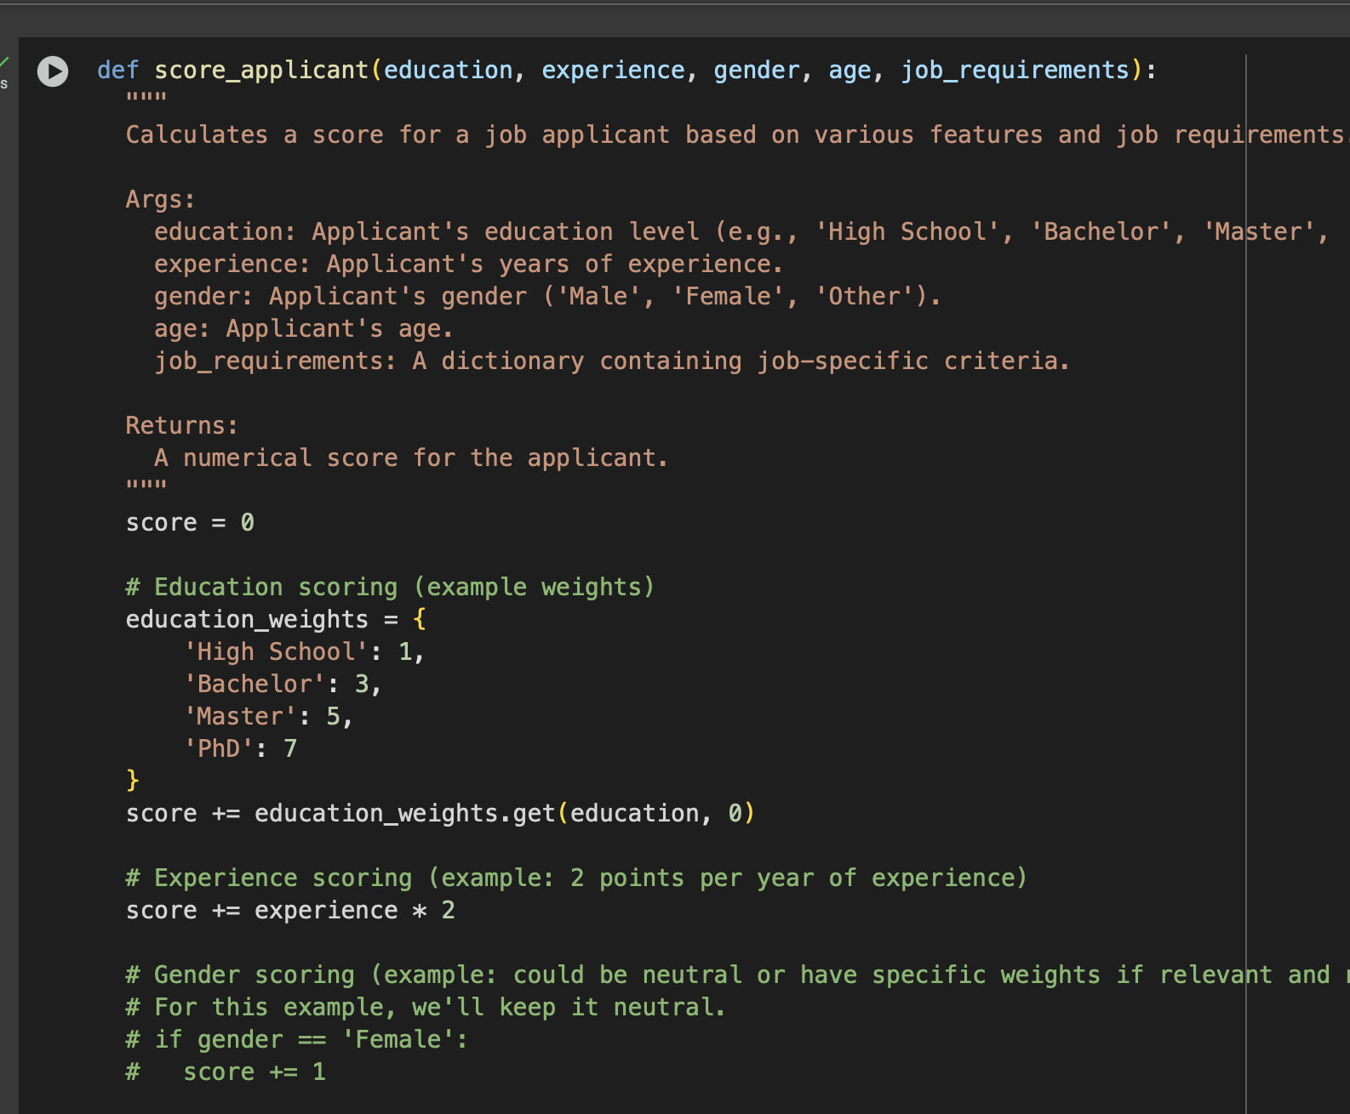

EXPLANATION 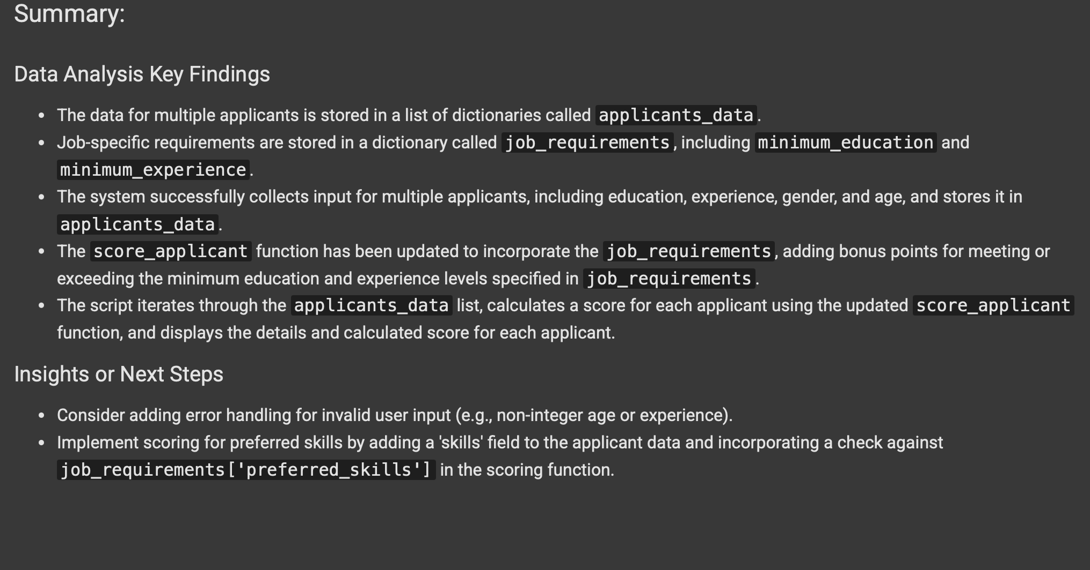OF THE CODE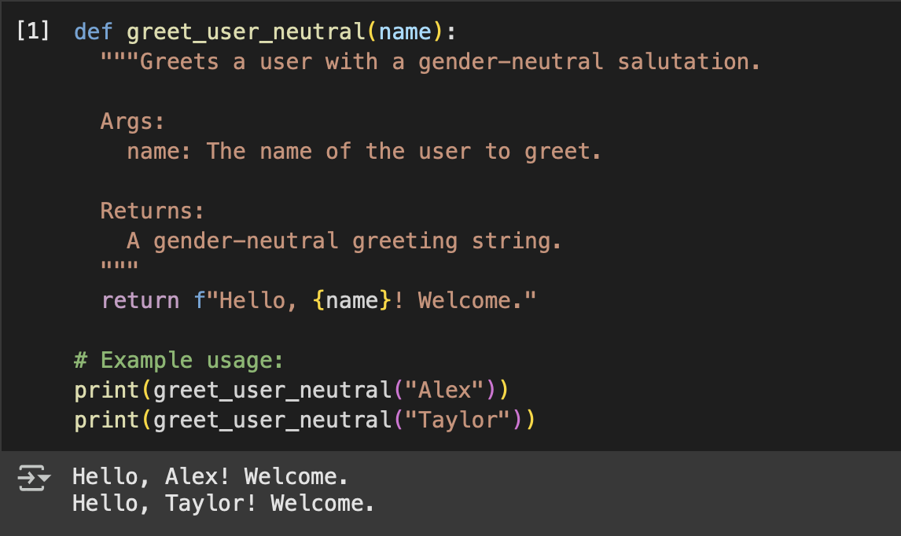

TASK 5:

CODE AND OUTPUT

EXPLANATION OF THE CODE:

